**Institute of Information Technology (IIT)**

Jahangirnagar University



**Lab Report: 06**

**Course Code: ICT-4104**

Submitted by:

Name: Md Shakil Ahmed

Roll No: 2013

Lab Date: 21-08-2023

Submission Date: 28-08-2023

**EXP.NO: 06**

**Name Of the Experiment:** IMPLEMENTATION OF LP FIR FILTER

**AIM:** To implement LP FIR filter for a given sequence.

**Software:** MATLAB

**Theory:** FIR filters are digital filters with finite impulse response. They are also known as non-recursive digital filters as they do not have feedback.

An FIR filter has two important advantages over an IIR design:

* Firstly, there is no feedback loop in the structure of an FIR filter. Due to not having a feedback loop, an FIR filter is inherently stable. Meanwhile, for an IIR filter, we need to check the stability.
* Firstly, there is no feedback loop in the structure of an FIR filter. Due to not having a feedback loop, an FIR filter is inherently stable. Meanwhile, for an IIR filter, we need to check the stability.

**FIR Filter Design**

An FIR filter is designed by finding the coefficients and filter order that meet certain specifications, which can be in the time-domain (e.g. a matched filter) and/or the frequency domain (most common). Matched filters perform a cross-correlation between the input signal and a known pulse-shape. The FIR convolution is a cross-correlation between the input signal and a time-reversed copy of the impulse-response. Therefore, the matched-filter's impulse response is "designed" by sampling the known pulse-shape and using those samples in reverse order as the coefficients of the filter.

When a particular frequency response is desired, several different design methods are common:

1. Window design method
2. Frequency Sampling method
3. Weighted least square design

**Window Design Method:**

In the window design method, one first designs an ideal IIR filter and then truncates the infinite impulse response by multiplying it with a finite-length window function. The result is a finite impulse response filter whose frequency response is modified from that of the IIR filter.

|  |  |  |  |  |  |
| --- | --- | --- | --- | --- | --- |
| Window Name | Transition Width (Approximate) | Transition Width (Exact) | Min. Stop Band Attenuation | MATLAB Command |  |
| Rectangular | 4𝜋/M | 8.1𝜋/M | 21 dB | B = FIR1(N, Wn, boxcar) |  |
| Bartlett | 8𝜋/M | 1.6𝜋/M | 25 dB | B = FIR1(N,Wn, bartlett) |  |
| Hanning | 8𝜋/M | 2.6𝜋/M | 44 dB | B=FIR1(N,Wn, hanning) |  |
| Hamming | 8𝜋/M | 6.6𝜋/M | 53 dB | B=FIR1(N,Wn,hamming) |  |
| Blackman | 12𝜋/M | 11𝜋/M | 74 dB | B=FIR1(N,Wn,blackman) |  |

**Methodology**

**Algorithm:**

Step I : Enter the pass band frequency (fp) and stop band frequency (fq).

Step II : Get the sampling frequency (fs), length of window (n).

Step III : Calculate the cut off frequency, fn

Step IV : Use boxcar, hamming, blackman Commands to design window.

Step V : Design filter by using above parameters.

Step VI : Find frequency response of the filter using matlab command freqz.

Step VII : Plot the magnitude response and phase response of the filter.

**Flow Chart:**

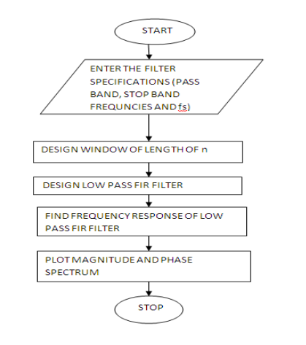

Fig-01: Flowchart

## 

## **PROGRAM For Rectangular Window:**

clc;

clearvars;

close all;

n = 20;

fp = 200;

fq = 300;

fs = 1000;

fn = 2 * fp / fs;

% Generate rectangular window

window = rectwin(n + 1);

% Design FIR filter using rectangular window

b = fir1(n, fn, window);

% Compute frequency response

[H, W] = freqz(b, 1, 128);

% Plot magnitude response

subplot(2, 1, 1);

plot(W/pi, abs(H));

title('Magnitude Response of LPF');

ylabel('Gain in dB');

xlabel('Normalized Frequency');

% Plot phase response

subplot(2, 1, 2);

plot(W/pi, angle(H));

title('Phase Response of LPF');

ylabel('Phase Angle');

xlabel('Normalized Frequency');

## 

## **Output Waveforms:**

## 

Fig 02: wavelength for rectangular window

## 

## **PROGRAM For Hanning Window:**

clc;

clear all;

close all;

n=20;

fp=200;

fq=300;

fs=1000;

fn=2*fp/fs;

window=hamming(n+1);

b=fir1(n,fn,window);

[H W]=freqz(b,1,128);

subplot(2,1,1);

plot(W/pi,abs(H));

title('magnitude response of lpf');

ylabel('gain in db-------->');

xlabel('normalized frequency------>');

subplot(2,1,2);

plot(W/pi,angle(H));

title('phase response of lpf');

ylabel('angle-------->');

xlabel('normalized frequency------>');

## **Output Waveforms:**

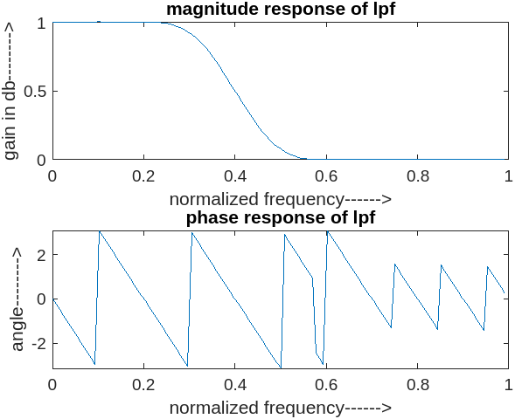

Fig 03: wavelength for hamming window

**Discussion:**

The practical execution of the LP FIR filter highlighted the significance of well-crafted filter coefficients. The selection of the windowing approach or frequency-sampling technique wielded a notable influence on the frequency response and the extent of stopband attenuation achieved by the filter. Additionally, the filter's order proved instrumental in striking a balance between achieving a steep roll-off and minimizing distortion in the output. Employing methods like the overlap-add or overlap-save technique for filter implementation emerged as vital for effectively managing memory resources, a particularly critical consideration when dealing with extended-duration signals.

**Conclusion:**

The application of the LP FIR filter demonstrated its efficacy in reducing high-frequency noise while retaining the essential low-frequency elements within the signal. The LP FIR filter's versatility was highlighted across diverse domains like audio manipulation, image enhancement, and the processing of biomedical signals.

**Viva Questions:**

**1. Define filter.**

Filter: A filter is a signal processing device or algorithm that manipulates the frequency content of a signal. Filters are used to remove or attenuate unwanted frequencies or components from a signal while allowing desired frequencies to pass through.

**2. What are the different types of filters?**

There are several types of filters:

1. Low-Pass Filter (LPF): Passes frequencies lower than a certain cutoff frequency.
2. High-Pass Filter (HPF): Passes frequencies higher than a cutoff frequency.
3. Band-Pass Filter (BPF): Passes frequencies within a certain range.
4. Band-Stop Filter (BSF) or Notch Filter: Attenuates frequencies within a certain range.
5. FIR (Finite Impulse Response) Filter: Only the input signal and its past values are used in computation.
6. IIR (Infinite Impulse Response) Filter: Depends on current and past inputs as well as past outputs.

**3. Why are FIR filters generally preferred over IIR filters in multirate (decimating and interpolating) systems/**

FIR filters are generally preferred over IIR filters in multirate (decimating and interpolating) systems because they are more stable. IIR filters can become unstable if the input signal contains frequencies that are outside of the filter's passband.

**4. Difference between IIR and FIR filters?**

The main difference between FIR and IIR filters is that FIR filters have a finite impulse response, while IIR filters have an infinite impulse response. This means that FIR filters are always stable, while IIR filters can become unstable if the input signal contains frequencies that are outside of the filter's passband. FIR filters are also typically more linear than IIR filters, which means that they do not introduce as much distortion to the signal. However, FIR filters are typically more computationally expensive than IIR filters.

**5. Differentiate ideal filter and practical filter responses.**

* Ideal filter response:
  + It has a sharp cutoff between the passband and stopband.
  + It has a linear phase response.
  + It is always stable.
* Practical filter response:
  + It has a gradual cutoff between the passband and stopband.
  + It has a non-linear phase response.
  + It may be unstable if the input signal contains frequencies outside of the passband.

**6. What is the filter specifications required to design the analog filters?**

The filter specifications required to design the analog filters are:

* Passband: The range of frequencies that are allowed to pass through the filter.
* Stopband: The range of frequencies that are blocked by the filter.
* Transition band: The region between the passband and the stopband.
* Attenuation: The amount of signal attenuation in the stopband.
* Ripple: The amount of signal variation in the passband.

**7. What is meant by frequency response of filter?**

The frequency response of a filter is a representation of how the filter modifies the input signal's frequency components. It's a plot or mathematical function that shows how the amplitude (gain) and phase of the signal change with respect to different input frequencies.

**8. What is meant by magnitude response?**

The magnitude response of a filter is the portion of the frequency response that represents the gain or amplitude change that the filter applies to different frequency components of the input signal. It's often depicted as a plot of gain against frequency and helps visualize how the filter amplifies or attenuates different frequency ranges.

**9. What is meant by phase response?**

The phase response of a filter is the angle of the filter's frequency response. It shows how the filter delays each frequency component of the signal.

**10. Difference between FIR low pass filter and high pass filter.**The main difference between FIR low pass filter and high pass filter is the frequency range that they pass. A low pass filter passes frequencies below a certain cutoff frequency, while a high pass filter passes frequencies above a certain cutoff frequency.

**References:**

[[1]https://www.geeksforgeeks.org/gibbs-phenomenon-rectangular-and-hamming-window-implementation/#:~:text=The%20Rectangular%20is%20not%20widely,of%20the%20signal's%20frequency%20spectrum.](%5b1%5dhttps://www.geeksforgeeks.org/gibbs-phenomenon-rectangular-and-hamming-window-implementation/#:~:text=The%20Rectangular%20is%20not%20widely,of%20the%20signal's%20frequency%20spectrum.)